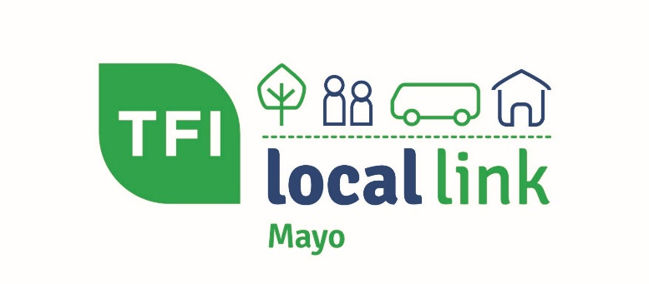

Recruitment Information Pack 2022

Compliance and Logistics Officer

Mayo Community Transport CLG TFI Local Link Mayo are seeking to appoint a Compliance and Logistic Officer who will bring exceptional performance, knowledge and professionalism to this role. The position involves working closely with colleagues throughout Mayo to ensure the risk and compliance requirements are achieved. It is ideal for a candidate who is eager to contribute and add substantial value in a dynamic and fast-paced compliance environment.

The following reflects typical duties the Compliance and Logistics Officer will be required to undertake: -

Job Specification:

- Oversee and input data on the Integrated Transport Management System (ITMS).
- Monitor service capacity.
- Review operator and driver training and accreditation to ensure compliance.
- Support the implementation and training of a Driver App and integrated ticketing.
- Implement the company health and safety framework to ensure operator and driver compliance.
- Carryout onsite service checks as required.
- Conduct an audit of bus stops and develop bus stop proposals for the Local Link Mayo services.
- Explore and promote the introduction of energy efficient vehicles.
- Plan, organise and evaluate IT and electronic data operations.
- Carryout route mapping as required.
- Compile risk and compliance reports monthly.
- Assisting in the development and coordination of the establishment of appropriate company policies and procedures as required.
- Ensuring timelines and projects outlined within the compliance and risk plan are adhered too.
- Procure and develop transport services.
- Working on other areas of the business as required.

Essential requirements:

- Third level degree and/or relevant qualifications preferrable.
- 3 years' experience in a compliance role preferably in a transport business.
- Excellent IT and reporting skills.
- Ability to understand and interpret regulatory requirements.
- Ability to communicate with colleagues and stakeholders at all business levels.
- Excellent organisation and time management skills with the ability to prioritise workload.
- Strong inter-personal, communication and presentation skills.
- Ability to manage multiple simultaneous tasks in a high pressure, deadline-driven environment.
- Full driving licence.

Hours of Work: 9:00am to 5:00pm (Monday to Friday)
Place of Work: Castlebar

General Information for applicants

Receipt of Application
Applications form must be submitted with a cover letter on the specified date. Late applications will not be accepted under any circumstances.

Acceptance of Application
Before you apply for the position, please familiarise yourself with the job specification and ensure that you meet the essential requirements. The acceptance of an application from a person, or the requesting of a candidate to attend for interview or any other test, is not to be regarded as an admission that such person possesses the prescribed qualifications, experience or other essential requirements. Prior to appointing any candidate to a position, TFI Local Link Mayo will make any enquiries it deems necessary to establish the suitability of that candidate.

Contact details
All correspondence with applicants will be sent by email. Please ensure that you have a valid email address and any change of applicant's email address or contact phone number should be notified immediately. During an active competition you are advised to check your email on a regular basis. The onus is on each applicant to ensure they are in receipt of all correspondence.

Canvassing
Any attempt by candidates themselves, or by any person(s) acting at their instigation, directly or indirectly, by means of written communication or otherwise, to canvas or otherwise influence in the candidate's favour any officer of Company or any person acting on behalf of the Company, will automatically disqualify the candidates for the position they are seeking.

Eligibility to compete
Eligibility to compete is conditional on applicants, where relevant, having the necessary requisite work permit/visa/permission to enable them to work legally in the Republic of Ireland. The onus is on each applicant to satisfy themselves that they meet this requirement.

Selection Procedures
In the event of a large number of applications TFI Local Link Mayo may shortlist on the basis of information provided in the application. It is thus essential that candidates provide full details of qualifications and work experience in the application.
Selection methods may include:
- Short listing of applicants based on information contained in the application form.
- Assessment centre with work sample test or other exercises.
- Competitive Preliminary interview.
- Competitive Final Interview.
Notification to attend interview will normally issue one week in advance. Candidates will be required to attend for interview or any other tests at their own expense. It is not possible to alter the allocated interview/test date or time.

Candidate Obligations
- Candidates who do not attend for interview or any other test when and where required, or who do not furnish any material or evidence that TFI Local Link Mayo may require in relation to their application, will have no claim for further consideration. Failure to furnish any documentation or other material within the required timelines will result in the candidate being deemed to have withdrawn their application from the competition.
- Candidates must produce satisfactory documentary evidence of all qualifications claimed by them if required. Any credit given to a candidate at interview in respect of such claims is provisional and liable to revision if the necessary supporting documents are not furnished as requested. TFI Local Link Mayo may request copies of academic transcripts and/or verify the authenticity of an applicant’s qualifications with the relevant institutions.
- Any candidate who supplies false or misleading information in their application may be disqualified. Candidates must not personate another candidate at any stage or interfere with or compromise the process in any way. Sharing information on the selection process through any means may result in you being disqualified.
- The use of recording equipment of any type is not permitted at any stage of the recruitment process. Any candidate found to be in breach of this provision will be disqualified from a competition.

Candidates Right to Review
The Company will consider requests for review of the selection procedures/decisions in accordance with our Recruitment Policy
The Company will endeavour to keep candidates informed of the progress of their application at the earliest possible date.

Offer of Appointment
Before any offer of appointment is made satisfactory references from two previous employers must be obtained. You will be asked to provide details of two referees at interview stage. The successful candidate will be subject to Garda/Police vetting.

Tenure
A full-time contract of employment will be offered of indefinite duration subject to continued funding. The appointee will be required to serve a three-month probationary period.

Salary
The Grade 4 standard local authority salary scale will apply to this position. Commencing at point 1 of the scale (€29,546).

Superannuation
Candidates appointed to positions at TFI Local Link Mayo will be offered the appropriate superannuation terms and conditions.

Data Protection
TFI Local Link will process any personal data provided by you in accordance with our Privacy Statement in relation to Personal Data and Recruitment.

This post is funded by the National Transport Authority.

